Assignment - 3

|  |  |
| --- | --- |
| Student Name/ID Number: | AGUNG YUDA PRATAMA / BDSE07-0922-076 |
| Unit Number and Title: | ACWD Module 5 – Web Development Foundations |
| Academic Year: |  |
| Unit Assessor: |  |
| Project Title: | Code the forms in Spring and Link it to MySQL Database |
| Issue Date: |  |
| Submission Date: | 28 February 2023 |
| Internal Verifier Name: |  |
| Date: | 28 February 2023 |



28 February 2023

Date:

Student signature:

I certify that the work submitted for this assignment is my own and research sources are fully acknowledged.

**Learner declaration**

|  |
| --- |
| **Purpose of this project** |
| **Purpose of this project**  To demonstrate your capabilities in the following areas:   * Code the Spring created in Mini Project 2 to integrate with database & with full functionality for the following   + Registration   + Update Profile   + Login & Log Out |
| **Submission Format** |
| 1. Screen capture of the working Registration, Update Profile, Login & Logout |
| **Project Brief & Guidance** |
| **Scenario:**  **Refer to the Project Scenario for the Module Project**  You have been approached by ‘ABC Jobs Pte Ltd’ as a website developer to develop a community portal for Software Developers. The project will be carried over through Module 3, Module 4, Module 5 and Capstone project. For this module the scope is to Design, Develop, Implement & Document Spring Framework Website.  The Scope of the Project is to design a Community Portal Similar to Linkedin.com. Users will be able to register in the portal using the Registration Page. Users of the portal can search for other users using various parameters such as First Name, Last Name, Company Name, City & Country. Users will be able to view the Public Profile of users after searching them. The portal allow users to login, request for forgotten password and Update their profile information  The scope of the project in this modules is for development of Spring Framework Website.  The scope of the project in this modules is to develop the database.  **The overview of the project is as below**  There are 2 types of users in this Community portal. They are   1. Software Programmer 2. Administrator |

|  |
| --- |
| **Software Programmer should be able to perform following functions in the portal**   1. Allow the programmers to register in the portal, show a thank you page & send a registration confirmation email. 2. Search & Find Other Programmers after login and view their profile. 3. Provide Login Page 4. Provide password retrieval functionality. 5. Update their Profile after logging in.   Following Functionality is part of Database Design & Will be enhanced as features as required in the Capstone Project, Depending on time availability.   1. Send Messages to Each Other on the Portal 2. Create Threads & Post Replies to a Thread 3. Post Job Opportunities in the Portal   **Administrator should be able to perform following functions in the portal**   1. Administer user data. 2. Send bulk email inviting programmers to register on the community portal   **The portal consist of the following Key pages (For Reference)**   1. Community Portal Home Page 2. Registration Page 3. Registration Confirmation Page 4. Update Profile Page 5. Search Users Page 6. List Search Results 7. Public Profile Page 8. Registration Confirmation Email 9. Login Page 10. Forget Password Page 11. Design the Forget Password Confirmation Page   Following Functionality is part of Database Design and will not be part of development & Will be enhanced as features are required in the Capstone Project, Depending on time availability.   1. Send Messages 2. Read Messages 3. Post in Message Board 4. List Message Board 5. Read A Thread 6. Post Job Opportunities 7. List Job Opportunities & Responses   **The scope of this assignment**  The scope is to develop coding on the Spring Project in Mini Project 2, Integrate the registration page with the database & create the models as required. |

1. Create registration page
2. Create update profile page
3. Create the login system

Provide Screen capture of the working Registration, Update Profile, Login & Logout

**The Answer**

1. **Create Registration Page**
   1. **Registration .jsp**

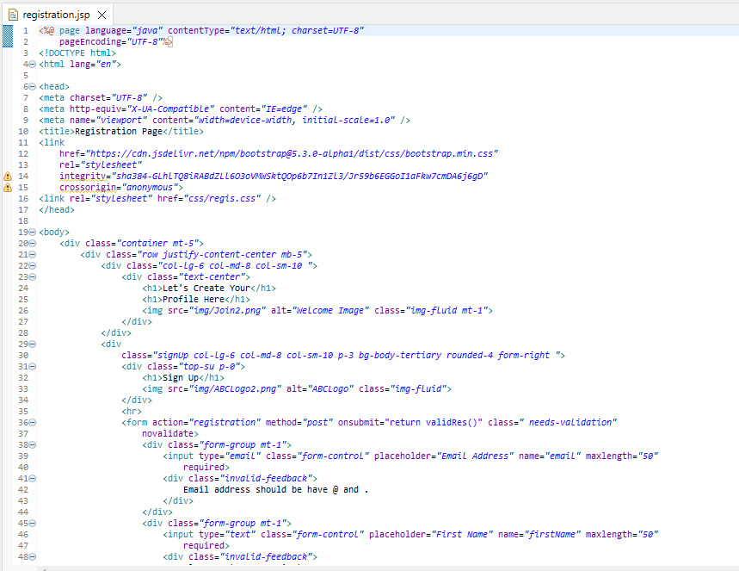

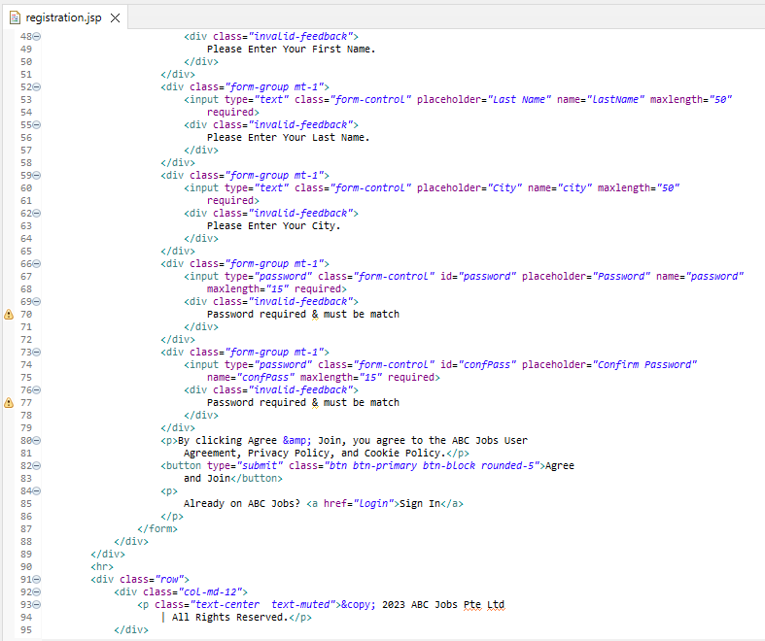

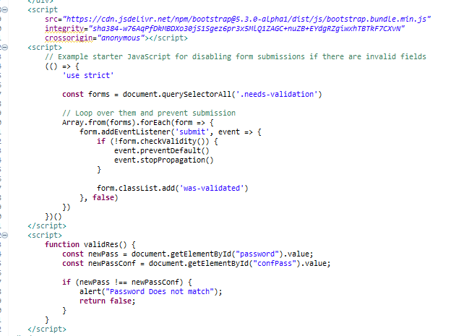

* 1. **Registration Controller**

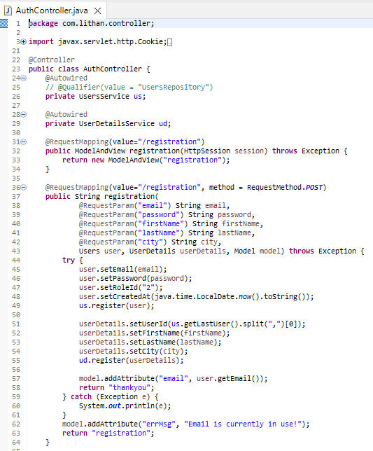

* 1. **Registration Result**

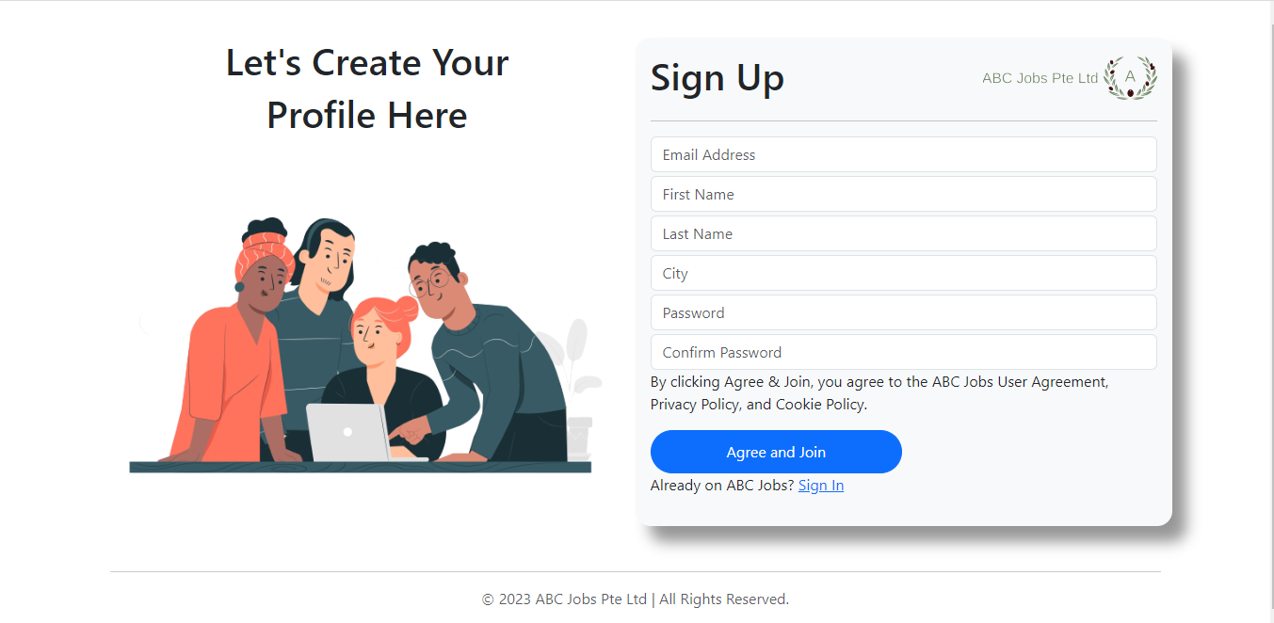

* 1. **Thank You Page**

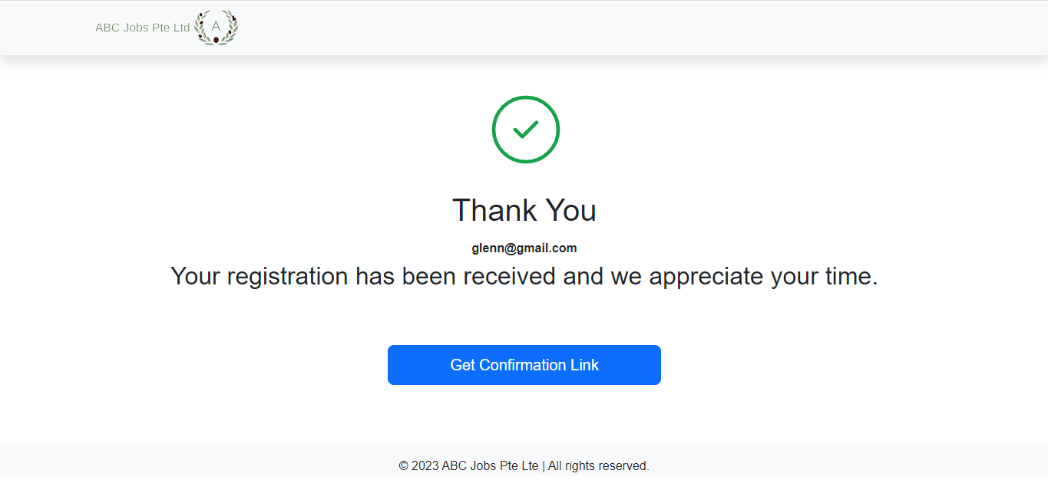

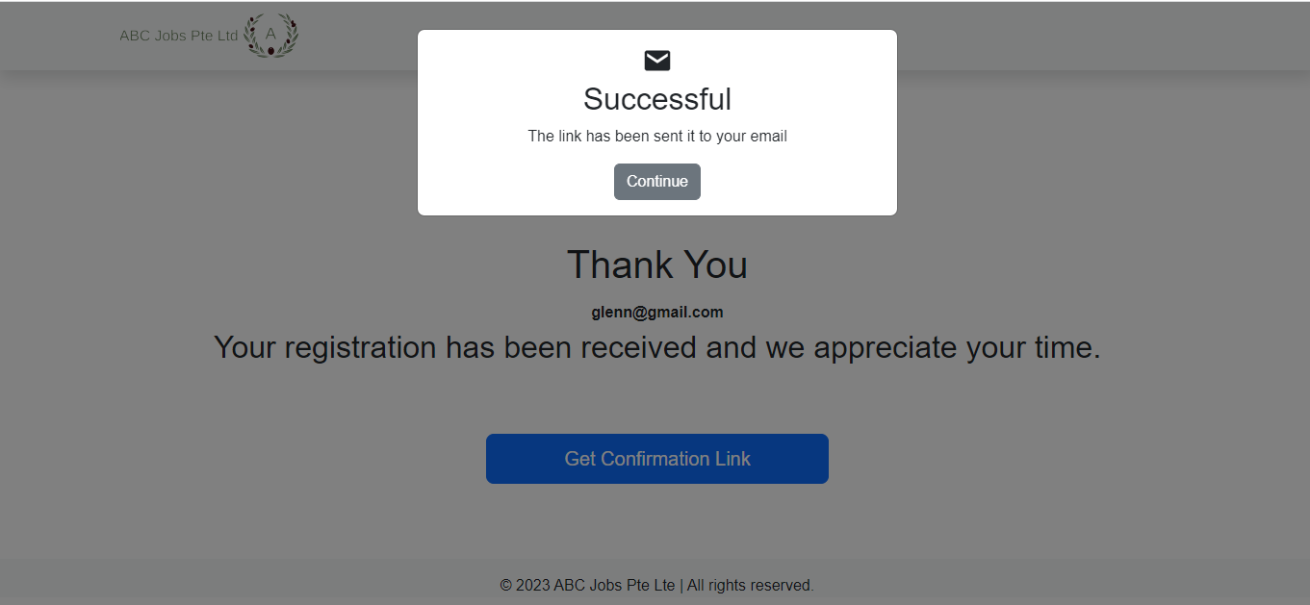

* 1. **Confirmation Page**

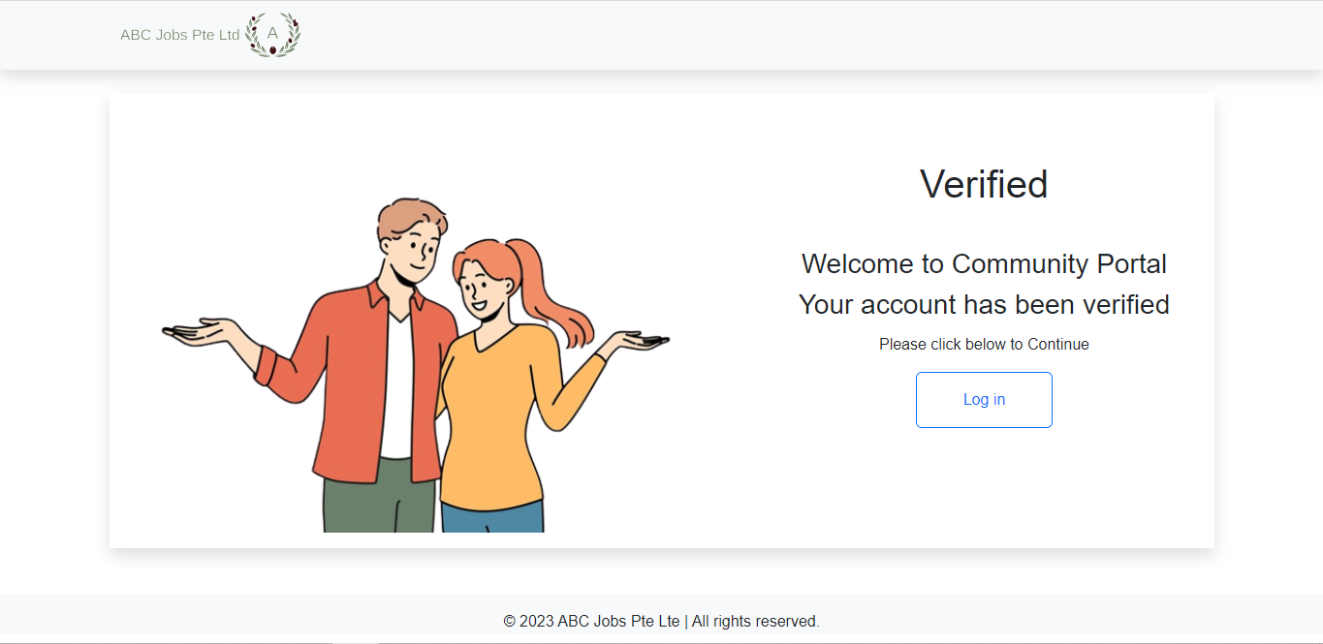

1. **Create Update Profile Page**
   1. **Update Profile .jsp**

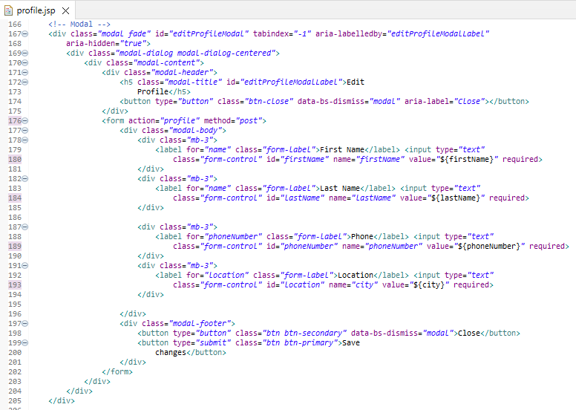

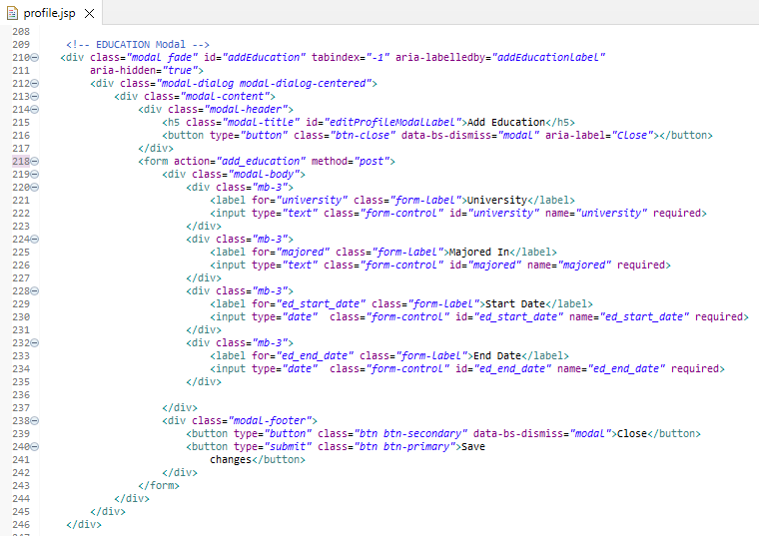

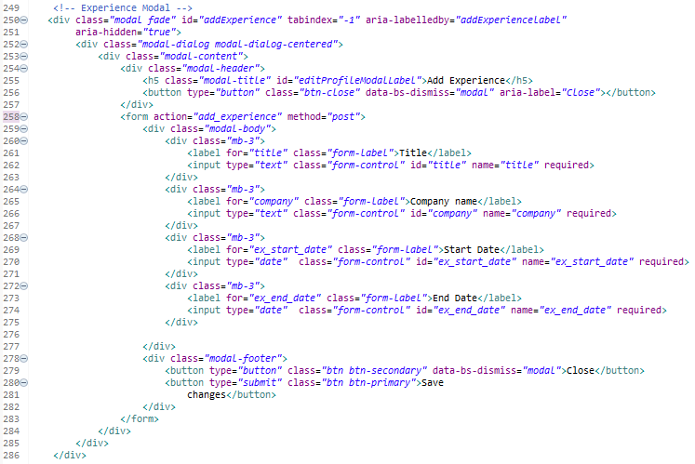

* 1. **Update Profile Controller**

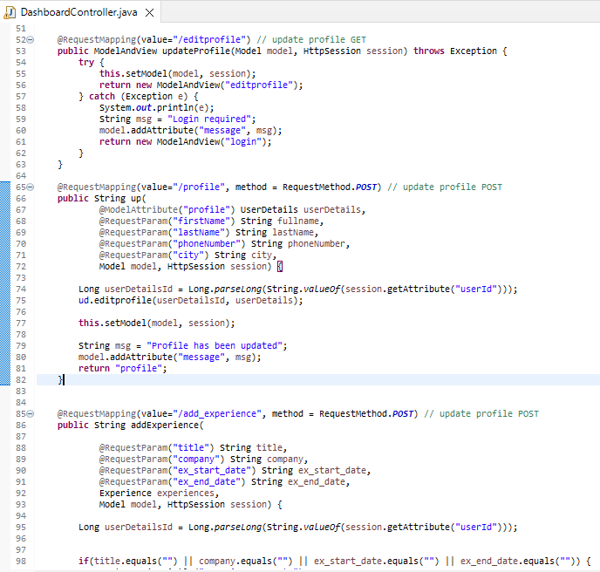

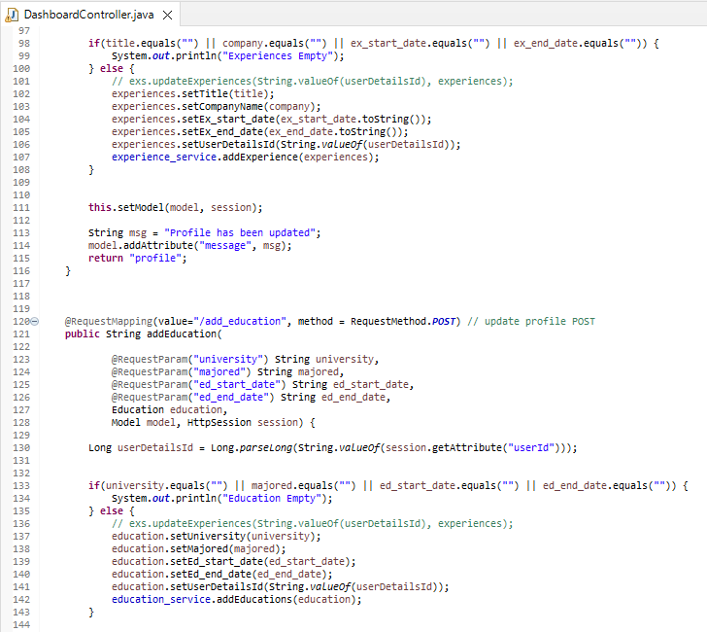

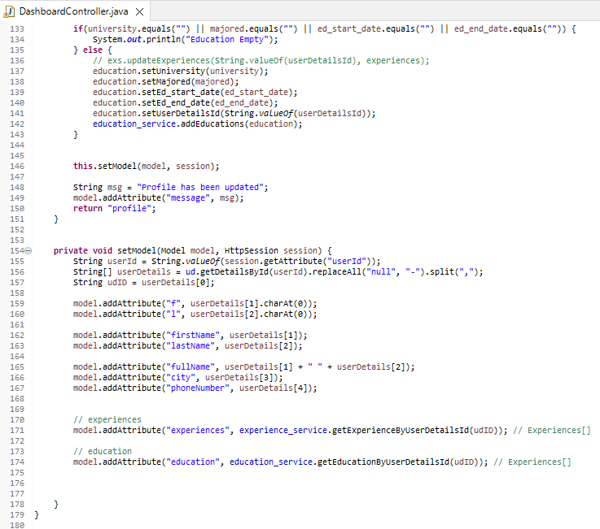

* 1. **Update Profile Result**

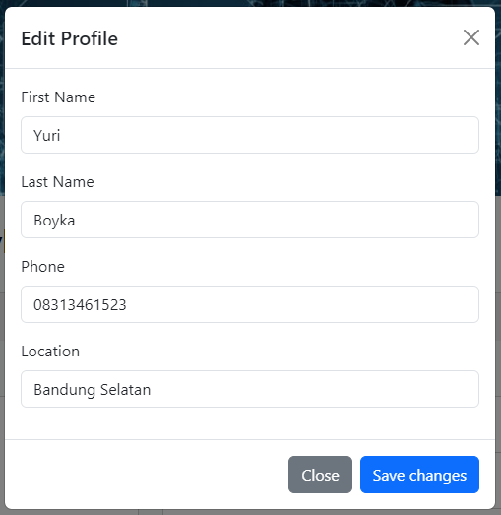 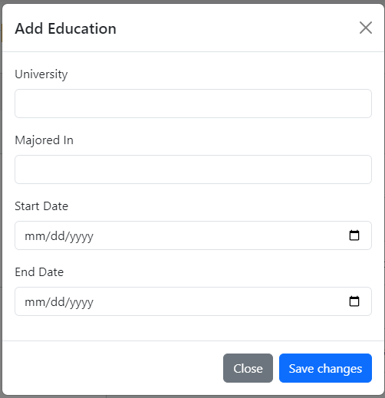

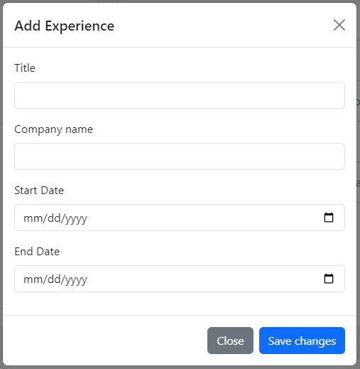

1. **Create Login System**
   1. **Login .jsp**

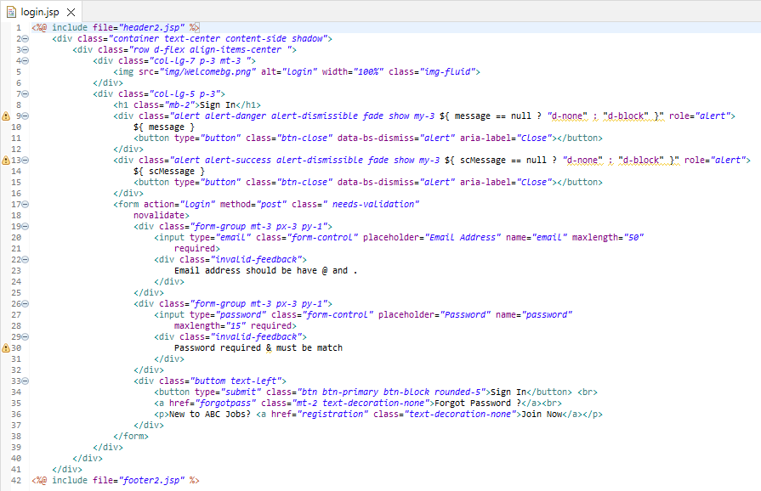

* 1. **Login Controller**

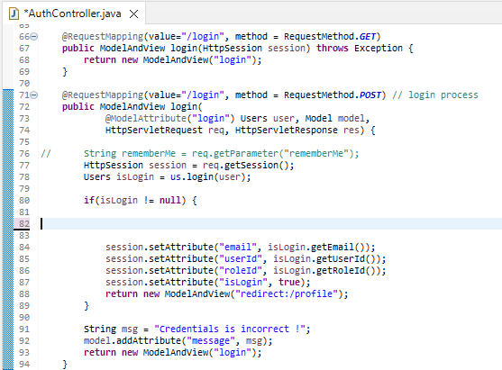

* 1. **Login Result**

